**TABLE OF CONTENT**

DECLARATION i

TABLE OF CONTENT ii

ABSTRACT v

CHAPTER ONE 1

GENERAL INTRODUCTION (PROJECT PROPOSAL) 1

1.0 Introduction 1

1.1 Subject and Field of Study. 2

1.2 Study Objective 3

1.2.1 General Objective 3

1.2.2 Specific Objective 3

1.3 Background of Study 4

1.4 Scope of Study 7

1.5 Justification or Significant of Study 8

1.6 Methodology 9

1.7 Expected Results of the Study 10

1.8 Presentation of thesis 10

1.9 Study work plan 11

CHAPTER TWO 12

LITERATURE REVIEW 12

2.0 Introduction 12

2.1 Overview of Tourism Management System. 12

2.2 Brief History of Job Application 14

2.3 Review of System. 16

2.3.1 System Feature 168

CHAPTER THREE 18

CRYSTALLIZATION OF THE PROBLEM 18

3.0 BACKGROUND/HISTORY OF THE STUDY 18

3.1 COMPONENTS/FEATURES OF THE PROPOSE SYSTEM 21

3.1.1 THE STRENGTH/ADVANTAGES OF THE PROPOSE SYSTEM 21

3.1.2 THE WEAKNESSES/DISADVANTAGES OF THE PROPOSE SYSTEM 21

CHAPTER 4 22

ANALYSIS OF THE PROPOSED SYSTEM 22

1.0 Overview of the proposed system 22

2.0 Functional Requirements 24

3.0 Non-functional Requirements 27

4.0 Major features/components of the proposed system 30

4.2 Benefits/Advantages of the proposed system 32

CHAPTER 5 34

DETAILED DESIGN OF THE PROPOSED SYSTEM 34

5.0 FUNCTIONAL PROCESSESS OF THE PROPOSED SYSTEM 34

5.0.1 The backend (Administrator’s‟ side) 36

5.1 ALGORITHIM OF THE PROPOSED SYSTEM 38

5.1.1 Job Applicant 38

5.1.2 Administrator side 38

5.2 FLOW CHART OF THE PROPOSED SYSTEM 39

FLOW CHART DIAGRAM 39

5.3 DATAFLOW DIAGRAM OF THE PROPOSED SYSTEM 40

DATA FLOW DIAGRAM 40

ENTITY RELATIONSHIP DIAGRAM 40

5.4 DATA DICTIONARY 42

5.4.1 DATABASE SCHEMA 42

User Table 42

Company table 43

Job table 44

Category table 45

Favoriye Job table 46

Job User table 46

Post table 45

Testimonial table 46

Profiles table 46

5.5 USE CASE DIAGRAM 49

CHAPTER 6 50

SYSTEM IMPLEMENTATION AND TESTING 50

6.0 IMPLEMNTATION 50

6.1 TESTING 51

CHAPTER 7 52

CUNCLUSION AND RECOMMENDATION 52

8.0 CONCLUSION AND RECOMMENDATION 52

# 

# ABSTRACT

In the quickly developing scene of enlistment and work, the conventional request for employment process is being upset by advanced advances. This venture presents the plan and execution of an inventive internet-based employment form framework pointed toward smoothing out the enrollment interaction for the two managers and occupation searchers. Utilizing client focused plan standards and state of the art web improvement innovations, the framework extends to a consistent and easy to use interface for employment opportunity searchers to look for employment opportunities, submit applications, and track their application situations with. Bosses benefit from powerful elements for posting position postings, overseeing candidate profiles, and effectively screening competitors. Through a blend of subjective client criticism and quantitative execution measurements, the framework's viability in upgrading the productivity and viability of the employment form process is assessed. Fundamental discoveries show a critical decrease in the time and assets expected for enlistment exercises, bringing about expanded efficiency for bosses and further developed fulfillment among work searchers.

# CHAPTER ONE

# GENERAL INTRODUCTION (PROJECT PROPOSAL)

## Introduction

In the present unique work market, the course of occupation looking and application has gone through a huge change with the coming of online innovations. The conventional strategies for submitting resumes and introductory letters through postal mail or in-person drop-offs have been generally supplanted by computerized stages that work with a smoothed out and proficient application process. This shift towards online request for employment frameworks has not just upset the manner in which work searchers connect with possible managers yet has additionally introduced new open doors and difficulties for associations looking to draw in and recruit top ability.

The point of this venture is to address the advancing requirements of both work searchers and businesses by planning and carrying out an inventive web-based employment form framework. By utilizing the most recent progressions in web improvement advancements and consolidating client focused plan standards, this framework is intended to offer a consistent and natural experience for all partners engaged with the enlistment cycle. Through a far-reaching examination of existing web-based employment form frameworks and a top to bottom comprehension of the necessities and inclinations of both work searchers and managers, this task tries to recognize key elements and functionalities that are fundamental for streamlining the request for employment process.

Besides, this task plans to assess the adequacy of the created web-based request for employment framework in working on the proficiency and viability of the enrollment cycle. By gathering subjective criticism from clients and dissecting quantitative execution measurements, we try to survey the framework's effect on different parts of the enrollment interaction, including time and asset investment funds, candidate fulfillment, and generally speaking enlistment results.

By and large, this task adds to the continuous computerized change of the enrollment business by giving a commonsense answer for associations hoping to modernize their employing processes in the computerized age. By offering experiences into the plan and execution of a viable internet-based request for employment framework, this venture expects to work with a more smoothed out and straightforward enrollment process that benefits both work searchers and bosses the same.

## **Subject and Field of Study.**

The field of study is Information Technology, which is applied in the employment industry in developing Online Job Application Systems.

## 1.2 Study Objective

### 1.2.1 General Objective

To create and execute a proficient web-based request for employment framework that upgrades the enrollment interaction for both work searchers and managers.

### 1.2.2 Specific Objective

The specific objectives of this study are:

1. Direct client examination and investigation to distinguish the key requirements, inclinations, and trouble spots of both work searchers and managers in the employment form process.
2. Decide fundamental highlights and functionalities expected for the web-based request for employment framework in view of the discoveries from client exploration and industry best practices.
3. Plan and foster an easy to understand and natural internet-based employment form stage that integrates the recognized elements and lines up with the necessities of both work searchers and bosses.
4. Lead ease of use testing and accumulate input from beta clients to distinguish regions for development and refine the framework iteratively.
5. Assess the exhibition of the created web-based employment form framework regarding proficiency, adequacy, client fulfilment, and effect on enrolment results
6. Work with consistent mix of the framework into the enrolment cycles of taking an interest manager, guaranteeing similarity with existing HR frameworks and work processes.
7. Give preparing and progressing backing to bosses and occupation searchers to actually use the internet-based request for employment framework and boost its advantages.
8. Execute strong safety efforts to shield delicate candidate information and guarantee consistence with information insurance guidelines like GDPR and CCPA.
9. Plan the framework engineering to be versatile and versatile to oblige future development and mechanical headways in the enrolment business.

## 1.3 Background of Study

In the development of enrollment processes, customary techniques have given way to online stages, driven by progressions in innovation and changes in competitor conduct. This progress has achieved huge advantages, including expanded effectiveness, more extensive reach, and diminished costs for the two bosses and occupation searchers. Notwithstanding, alongside these benefits come difficulties, for example, worries about information security, possible separation in web-based choice cycles, and issues connected with the ease of use of online request for employment frameworks.

To address these difficulties and upgrade client experience, online request for employment frameworks should integrate client focused plan standards and best practices. Research in this space underlines the significance of planning natural connection points and advancing client commitment to upgrade candidate fulfillment and further develop enlistment results.

According to the business' viewpoint, fruitful web-based enlistment systems require a comprehension of their inclinations, necessities, and problem areas in the enrollment cycle. Contextual investigations of associations that have actually executed internet-based employment form frameworks can give significant experiences into best practices and achievement factors.

Understanding candidate conduct and inclinations is fundamental for planning viable internet-based request for employment frameworks. Factors affecting internet-based quest for new employment conduct, like the utilization of innovation and online entertainment, should be considered to make stages that reverberate with current work searchers.

Mechanical headways keep on molding the scene of enlistment programming, with arising advances, for example, simulated intelligence driven candidate screening, chatbots for competitor commitment, and video talking with stages. Similar examinations of various enrollment programming arrangements can illuminate the determination and improvement regarding on the web employment form frameworks.

Lawful and moral contemplations assume a pivotal part in web-based enlistment rehearses, with guidelines overseeing regions like enemy of segregation, information security, and equivalent work a potential open door. Consistence with these guidelines is fundamental to guarantee decency, straightforwardness, and legitimate consistence in web-based enlistment processes.

The Coronavirus pandemic has sped up the reception of virtual enrollment advancements, with remote recruiting works on turning out to be more pervasive. Understanding the effect of the pandemic on enlistment patterns and the reception of virtual enrollment advances is significant for adjusting on the web request for employment frameworks to current and future necessities.

Assessment measurements and execution markers, for example, time-to-recruit, cost-per-enlist, candidate transformation rates, and candidate fulfillment scores, give important experiences into the viability of online request for employment frameworks. Observing and investigating these measurements can assist associations with enhancing their enrollment processes and further develop results.

Looking forward, future patterns in web-based employment form frameworks incorporate the mix of artificial intelligence, AI, blockchain, and computer-generated reality advancements. Guessing on these future headings can educate the advancement regarding inventive and state of the art online employment form frameworks.

## 1.4 Scope of Study

This examination venture will zero in on looking at online employment form frameworks inside a particular topographical district, focusing on different businesses and areas. The review will basically envelop associations of various sizes, including independent companies, global partnerships, and non-benefit associations.

The examination will target explicit gatherings inside the gig market, like ongoing alumni, mid-vocation experts, and people looking for passage level positions. It will investigate the points of view and encounters of both work searchers and businesses utilizing on the web employment form frameworks, giving experiences into their necessities, inclinations, and difficulties.

The review will focus on unambiguous innovative parts of online employment form frameworks, including versatile similarity, computer-based intelligence mix, and network safety measures. It will survey these frameworks in view of explicit assessment measurements, for example, client fulfillment, productivity gains, and cost-adequacy.

## 1.5 Justification or Significant of Study

The proposed research can be justified by providing answers to the questions below:

1. Does the research extend the understanding of the?

Is the phenomenon being investigated?

1. Does it elaborate, extend or fill in gaps in present knowledge?
2. iii. Finally, will it give the expected results?

After putting these above-mentioned questions into concern, I believe that this research is worth doing. Using the manual system as the existing system to be investigated, in which the mode of operation is done manually, a certain level of bias will be experienced.

This thesis will act as reference material for those who use this project material. It will also provide information to other researchers.

## 1.6 Methodology

The research for this study can be done through the use of observation and questionnaires.

With the software development process model to be employed, I plan to use the Waterfall model because the requirements are known and understood.

To realize the objectives of this research, it is important to apply the appropriate strategy in achieving the set goals. The methodology employed in the course of this study is to first outline the set of requirements to be met by the proposed system, then envisage and implement the design of the system, using HTML and PHP for the design and MySQL for building the database.

## 1.7 Expected Results of the Study

By the end of the research, it is expected that the findings of this project will help improve the management of job application and ease the stress associated with the existing manual system in various job application systems.

## 1.8 Presentation of thesis

The documentation of this project shall be divided into eight (8) chapters. Each chapter shall consist of different but interrelated components. The categories of the chapters will be summarized as follows:

Chapter One: This chapter shall describe the general

introduction of the subject matter under study;

Chapter two will primarily consist of a comprehensive literature review of the subject under study;

Chapter three shall talk about the Crystallization of the problem under research:

Chapter four will discuss the analysis of the proposed system under study;

Chapter five will discuss the detailed design of the proposed system;

Chapter six will consist of the System Implementation and Testing:

Chapter seven shall consist of the System Documentation and the last chapter which is

Chapter eight shall highlight the conclusions and recommendations and further work.

## 1.9 Study work plan

With regards to timelines, the development of the system I propose will be completed in two aspects:

The first aspect shall comprise an introduction, investigation, system analysis, and design and will be expected to be completed in August 2024.

The second aspect will consist of the detailed design and the implementation of the proposed system including the final presentation. It will be expected to be completed in September 2024.

# CHAPTER TWO

# LITERATURE REVIEW

## Introduction

This chapter shows a literature review considered relevant to the research and related state of the arts. Some of the related works prove the benefits as well as the challenges job applicants faces.

In this chapter, I will begin by discussing an overview of Job application as the basis of this research work followed by a brief history of the Job application system. Types of Job application systems will be discussed before looking at certain academic work undertaken with a bias toward the subject matter under consideration.

## 2.1 Overview of Tourism Management System.

This exploration undertaking will zero in on looking at online employment form frameworks inside a particular topographical district, focusing on different ventures and areas. The review will basically envelop associations of various sizes, including independent ventures, worldwide companies, and non-benefit associations.

The exploration will envelop different parts of online employment form frameworks, including client experience plan, mechanical patterns, lawful and moral contemplations, and future headings. It will analyze the development of enrollment processes, the advantages and difficulties of online enlistment, and the viewpoints of both work searchers and bosses.

The extent of studies will zero in on unambiguous topographical districts, ventures, and interest groups, with a relative examination of various web-based employment form frameworks. Assessment measurements will be utilized to survey the viability and productivity of the created framework, giving experiences into client fulfillment, proficiency gains, and cost-adequacy.

In general, the undertaking looks to add to the continuous computerized change of the enlistment business by giving a cutting edge and proficient web-based request for employment framework that addresses the issues of both work searchers and bosses. By tending to scratch difficulties and integrating arising innovations, the framework means to streamline the enlistment interaction and upgrade the general insight for all partners involved. The exploration will target explicit gatherings inside the gig market, like ongoing alumni, mid-vocation experts, and people looking for section level positions. It will investigate the viewpoints and encounters of both work searchers and businesses utilizing on the web employment form frameworks, giving experiences into their requirements, inclinations, and difficulties.

Moreover, the exploration might include a similar investigation between various web-based employment form frameworks, featuring their assets, shortcomings, and novel elements. It will likewise remember an examination of future patterns and advancements for online request for employment frameworks, giving bits of knowledge into expected headways and regions for improvement.

## 2.2 Brief History of Job Application

The idea of online request for employment frameworks arose in the last part of the 1990s with the rising ubiquity and openness of the web. Before this, work searchers commonly depended on conventional strategies like paper classifieds, organizing, and actual resumes submitted face to face or through mail.

In the mid-2000s, the original of online work sheets and quest for new employment motors started to show up, extending to a unified stage for employment opportunity searchers to look and go after position openings. Sites like Monster.com, CareerBuilder, and Craigslist reformed the pursuit of employment process by giving a huge data set of occupation postings open to anybody with web access.

As web use turned out to be more inescapable and innovation progressed, online request for employment frameworks developed to offer extra highlights and functionalities. These included instruments for making and transferring resumes, customized work cautions, and candidate global positioning frameworks (ATS) for bosses to proficiently oversee requests for employment more.

With the ascent of web-based entertainment and expert systems administration stages like LinkedIn in the last part of the 2000s and mid-2010s, online employment form frameworks consolidated social selecting highlights, permitting bosses to associate with and enlist applicants through interpersonal organizations.

Lately, headways in computerized reasoning (man-made intelligence) and AI have additionally changed web-based employment form frameworks. Simulated intelligence fueled devices are currently utilized for continue screening, up-and-comer coordinating, and chatbot-based applicant commitment, smoothing out the enlistment interaction and further developing proficiency for both work searchers and bosses.

Today, online request for employment frameworks keeps on developing with the reception of portable innovations, video talking with stages, and virtual enrollment occasions. The Coronavirus pandemic further sped up the reception of virtual enrollment advancements, featuring the significance of online request for employment frameworks in working with remote recruiting processes.

Looking forward, online request for employment frameworks is supposed to keep developing with the reconciliation of arising advancements, for example, blockchain, augmented reality, and prescient examination, giving inventive answers for meet the changing necessities of the enlistment business.

## 2.3 Review of System.

### 2.3.1 System Features

**Features.**

* Comprehensive job search with filters for location, industry, experience level, etc.
* Ability to create new job.
* Ability to update and delete job.
* Ability to update company profile.
* Ability to view job applications.
* Ability to save job searches.
* Ability to upload resume and cover letter.
* Apply directly to job listings within the app.
* Access to company profiles, reviews, and salary information.
* View all total number of users, companies and jobs.
* View the number of users visited the app for each day.
* Update and delete company.
* Update and delete user.
* Update and delete job category.
* Update and delete testimonial.
* Update and delete job.
* Update and delete post.
* Customize platform settings and configurations.

# CHAPTER THREE

## CRYSTALLIZATION OF THE PROBLEM

This chapter presents an outline of the various aspects of the research with regards to the background of online job application system, the components of the existing system as well as the strengths and weakness of the system used by job seekers.

### 3.0 BACKGROUND/HISTORY OF THE STUDY

The development of enrollment processes has seen a critical shift towards online techniques in ongoing many years. Customary enrollment techniques, depending on roads like paper commercials and actual resumes, have step by step been supplanted by online stages. This progress has been powered by headways in innovation and changes in competitor conduct, prompting the rise of online employment form frameworks as a pervasive method for associating position searchers with bosses.

Examination into online request for employment frameworks has featured different advantages related with this method of enrollment. These remember expanded effectiveness for the recruiting system, more extensive arrive at in drawing in up-and-comers, and diminished costs for the two managers and occupation searchers. In any case, close by these benefits come difficulties, for example, concerns in regards to information protection, likely segregation in web-based choice cycles, and issues connected with the ease of use of online request for employment frameworks.

Client Experience (UX) plan assumes a significant part in the viability of online employment form frameworks. Studies accentuate the significance of planning natural points of interaction and advancing client commitment to upgrade candidate fulfillment and further develop enrollment results. Understanding the viewpoints of bosses is additionally fundamental, as their inclinations, prerequisites, and problem areas impact the plan and usefulness of online employment form frameworks.

Dissecting candidate conduct in the web-based pursuit of employment and application process gives experiences into factors affecting application accommodation and occupation inclinations. Also, keeping up to date with mechanical patterns in enrollment programming is fundamental. Arising advances, for example, man-made intelligence driven candidate screening, chatbots for up-and-comer commitment, and video talking with stages are molding the enlistment scene and affecting the plan of online request for employment frameworks.

Lawful and moral contemplations are vital in the turn of events and execution of online employment form frameworks. Consistence with guidelines overseeing information assurance, hostile to separation regulations, and equivalent business opportunity rules is pivotal to guarantee reasonableness, straightforwardness, and legitimate consistence in enlistment processes.

The Coronavirus pandemic has sped up the reception of virtual enrollment advancements, featuring the significance of online employment form frameworks in working with remote recruiting processes. Assessing the viability of these frameworks requires the distinguishing proof of key execution pointers (KPIs) and measurements, for example, time-to-enlist, cost-per-recruit, candidate transformation rates, and candidate fulfillment scores.

Looking forward, future patterns and developments in web-based employment form frameworks incorporate the mix of simulated intelligence, AI, blockchain, and computer-generated reality advancements. These advancements hold the possibility to additionally streamline the enlistment interaction and improve the general client experience for both work searchers and bosses.

most of the existing system lacks the following features;

1. Career Path Planning
2. Skill Assessment Tools
3. Professional Networking Events
4. Mentorship Programs
5. Remote Work Opportunities

## 3.1 COMPONENTS/FEATURES OF THE PROPOSE SYSTEM

### 3.1.1 THE STRENGTH/ADVANTAGES OF THE PROPOSE SYSTEM

These are the various features/advantages that will be included in the proposed system:

* + User Registration and Profile Creation
  + Advanced Job Search
  + Saved Searches
  + Resume Upload and Creation
  + Cover Letter Submission
  + Company Profile Creation
  + Job Posting and Management
  + Resume Database Access
  + Applicant Tracking System (ATS)
  + Candidate Matching

### 3.1.2 THE WEAKNESSES/DISADVANTAGES OF THE PROPOSE SYSTEM

These are the various disadvantages that will be available in the proposed system:

1. The system will be run online of which it cannot be used offline.
2. It will require some form of training before the system can be used

# CHAPTER 4

## ANALYSIS OF THE PROPOSED SYSTEM

## Overview of the proposed system

The proposed employment form framework addresses a groundbreaking way to deal with present day enlistment, intending to give a consistent and effective stage for work searchers and bosses the same. Through a fastidious mix of state-of-the-art innovation and client driven plan standards, the framework vows to rethink the enrollment experience by offering a far-reaching set-up of elements custom-made to meet the different necessities of the two players.

For work searchers, the framework will flaunt a natural and outwardly captivating UI, guaranteeing easy route and openness across different gadgets. High level hunt functionalities will engage clients to refine their employment inquiries in light of explicit rules, while customized work alarms will keep them informed about applicable open doors progressively. Continue building instruments incorporated inside the stage will empower clients to create proficient continues easily, supplemented by a unified application following dashboard that gives perceivability into the situation with their applications.

Bosses, then again, will profit from smoothed out enrollment processes worked with by the framework's powerful highlights. From making itemized organization profiles to posting and overseeing position postings, businesses will approach an easy-to-use interface that works on each step of the employing venture. A coordinated Candidate Global positioning framework (ATS) will offer strong competitor the executive’s capacities, combined with cutting edge applicant matching calculations that distinguish the most reasonable contender for each position. Interview booking devices and exhaustive examination and detailing elements will additionally upgrade productivity and dynamic all through the enlistment cycle.

Besides, the framework will extend to a scope of advantages for both employment opportunity searchers and bosses past the center enrollment functionalities. Straightforward correspondence channels and customized encounters will encourage trust and responsibility, while admittance to vocation advancement assets and expert systems administration valuable open doors will engage work searchers to seek after their profession yearnings. For bosses, upgraded business marking components and information driven bits of knowledge will add to long haul achievement and supportability, situating associations as managers of decision in the serious work market.

Basically, the proposed request for employment framework epitomizes an all-encompassing way to deal with present day enrollment, driven by a pledge to conveying unrivaled client encounters and working with significant associations between work searchers and bosses. By utilizing innovation to its fullest potential and focusing on the different necessities of partners, the framework tries to reclassify the fate of enlistment and engage people and associations to flourish in the consistently developing position market.

### Functional Requirements

The web-based employment form framework is intended to address the issues of both work searchers and bosses by giving a thorough arrangement of utilitarian necessities that guarantee the framework's viability and ease of use.

For work searchers, the framework should incorporate elements that work with the pursuit of employment process, beginning with client enlistment and validation to make secure records. Clients’ ought to have the option to look for work postings in light of different standards, for example, area, industry, work title, and pay range. Progressed sifting choices ought to be accessible to refine list items and further develop exactness.

Work searchers should likewise have the option to submit requests for employment consistently through the framework, including transferring their resumes and introductory letters. The framework ought to give devices to overseeing resumes, permitting clients to transfer, alter, and tweak their resumes inside the stage. Also, clients ought to have the option to follow the situation with their requests for employment, getting warnings for updates and correspondence from managers.

For businesses, the framework ought to help the creation and the executives of organization profiles, permitting managers to feature their organization culture, mission, and employment opportunities. Managers should have the option to post employment opportunities with nitty gritty sets of responsibilities, capabilities, and application cutoff times. The framework ought to incorporate a Candidate Global positioning framework (ATS) for bosses to follow and oversee requests for employment effectively, including screening, shortlisting, and correspondence with candidates.

Specialized apparatuses are fundamental for both work searchers and managers inside the framework. The framework ought to work with consistent correspondence between work searchers and businesses, taking into account informing, interview booking, and announcements. Clients’ ought to get warnings for new messages and application updates to remain informed all through the enlistment interaction.

Examination and revealing highlights are critical for checking and assessing enrollment adequacy. The framework ought to give investigation and announcing highlights to both work searchers and managers, including measurements, for example, application status, quest for new employment action, and enlistment patterns. Clients’ ought to have the option to produce reports and envision information to acquire experiences into enlistment execution and pursue informed choices.

At last, the framework should be fit for coordinating with outer frameworks like HRIS, email stages, and online entertainment stages for consistent information trade and correspondence, guaranteeing a consistent client experience across various stages and frameworks.

Generally, these practical necessities structure the underpinning of the web-based employment form framework, guaranteeing that it addresses the issues of both work searchers and managers while conveying a consistent and proficient client experience all through the enlistment cycle.

### Non-functional Requirements

The following are the non-functional requirements of our proposed online tourism management system:

1. Execution: The framework ought to be responsive and ready to deal with countless simultaneous clients without huge execution corruption. Reaction times for undertakings, for example, pursuit of employment, application accommodation, and page stacking ought to be inside satisfactory cutoff points.
2. Versatility: The framework ought to be versatile to oblige expanding client traffic and developing information volumes after some time. It ought to help flat and vertical scaling to deal with changes popular and keep up with execution.
3. Unwavering quality: The framework ought to be profoundly solid, with negligible personal time and vigorous blunder taking care of systems set up. It ought to have reinforcement and recuperation methodology to guarantee information respectability and accessibility in case of framework disappointments.
4. Security: The framework ought to stick to industry-standard security conventions and encryption systems to safeguard client information and delicate data.

Access controls ought to be carried out to guarantee that main approved clients can get to and adjust information inside the framework.

1. Accessibility: The framework ought to be accessible every minute of every day, with planned support and margin time kept to a base and imparted to clients ahead of time. High accessibility setups, for example, load adjusting and failover components ought to be executed to guarantee ceaseless assistance accessibility.
2. Convenience: The framework ought to be easy to understand and natural, with make route ways and instinctive points of interaction for both work searchers and managers. Availability highlights ought to be integrated to guarantee that the framework is usable by people with inabilities.
3. Similarity: The framework ought to be viable with an extensive variety of internet browsers, gadgets, and working frameworks to guarantee openness for all clients. Similarity testing ought to be led to check that the framework performs reliably across various stages.
4. Practicality: The framework ought to be planned considering seclusion and extensibility, taking into account simple support and future improvements. Code ought to be indisputable and stick to coding guidelines to work with investigating and code upkeep by engineers.
5. Administrative Consistence: The framework ought to consent to pertinent information insurance guidelines, for example, GDPR, guaranteeing that client information is taken care of safely and as per legitimate necessities. Consistence with industry norms and best practices in enrollment and business, like equivalent work an open door (EEO) rules, ought to likewise be guaranteed.
6. Execution Checking and Logging: The framework ought to incorporate checking and logging capacities to follow framework execution measurements, distinguish peculiarities, and investigate issues proactively. Logs ought to be produced for client exercises, framework occasions, and blunders to work with examining and investigating.

### 4.0 Major features/components of the proposed system

* User Registration and Profile Creation
* Advanced Job Search
* Resume Upload and Creation
* Cover Letter Submission
* Ability to create new job.
* Ability to update and delete job.
* Ability to update company profile.
* Ability to view job applications.
* Ability to save job searches.
* Apply directly to job listings within the app.
* Access to company profiles, reviews, and salary information.
* View all total number of users, companies and jobs.
* View the number of users visited the app for each day.
* Update and delete company.
* Update and delete user.
* Update and delete job category.
* Update and delete testimonial.
* Update and delete job.
* Update and delete post.
* Customize platform settings and configurations

For Employers/Companies:

* + - Create new jobs
    - Update and delete job
    - View all company jobs
    - Update company profile
    - Update company logo and banner
    - Review and manage job applications
    - Manage company profile and branding

## 4.2 Benefits/Advantages of the proposed system

There are numerous advantages/benefits that CareerLink is going provide and these are some of them:

* + 1. Further developed Proficiency: The framework smoothest out the pursuit of employment and enrollment process for both work searchers and managers, decreasing the time and exertion expected to secure and fill position openings.
    2. Upgraded Availability: Occupation searchers can get to the stage from anyplace with a web association, expanding openness to open positions paying little mind to area or time requirements.
    3. Expanded Perceivability: Bosses can arrive at a more extensive pool of competitors by posting employment opportunities on the stage, expanding perceivability and drawing in additional certified candidates.
    4. Cost Reserve funds: The framework lessens conventional enrollment costs related with publicizing employment opportunities through print media or outsider offices, bringing about cost investment funds for managers.
    5. Further developed Up-and-comer Quality: The framework works with competitor matching in view of abilities and capabilities, bringing about greater candidates who are more qualified to the gig prerequisites.
    6. Straightforwardness: Occupation searchers can follow the situation with their applications and get constant updates, encouraging straightforwardness and responsibility all through the enrollment cycle.
    7. Information Driven Independent direction: The framework gives investigation and detailing highlights that empower managers to follow enrollment measurements and pursue information driven choices to upgrade their employing systems.
    8. Upgraded Client Experience: The stage offers an easy-to-understand interface, customized work cautions, and specialized devices, improving the general client experience for work searchers and bosses.
    9. Versatility: The framework is adaptable and can oblige expanding client traffic and developing information volumes over the long haul, guaranteeing adaptability to satisfy future needs.
    10. Consistence: The framework complies to information insurance guidelines and industry principles, guaranteeing consistence with legitimate prerequisites and safeguarding client information.
    11. Incorporation: The framework coordinates with existing HR frameworks and programming, smoothing out enrollment processes and upgrading information the executives and joint effort among partners.
    12. Brand Perceivability: Managers can make itemized organization profiles to feature their image, culture, and values, expanding brand perceivability and drawing in top ability.

# CHAPTER 5

## DETAILED DESIGN OF THE PROPOSED SYSTEM

This chapter gives detailed accounts of the design of the proposed system. Here the functional processes, algorithm and flowchart of the processes as well as the data dictionary are discussed.

## 5.0 FUNCTIONAL PROCESSESS OF THE PROPOSED SYSTEM

In order to design the system, the functional processes of the system must be clearly outlined. This is divided into two parts: The frontend (Job applicant ‟ side) and the backend (Administrators side). Both parts are designed to provide the functional processes of the proposed system.

The frontend (Job applicant ‟ side)

1. **Create account:** The signup page is the start page and initial page of the application. This is where job applicant first visits to sign up or create account. All the information submitted via the create account form is added to the database and enable the users to login into the system.
2. **Login:** This provides secure access functionality into the system, where job applicant scan login to the system. Here the job applicant login using the password and an id that is automatically generate for the job applicant s he or she provided during the creating account process.
3. **Home page:** This is the main page of the job applicant’s side. All other activities are linked to this activity. Activities linked to this home page are:
4. **Job application Page:** This is where job applicant s can choose a job application that suites his or her budget.
5. **Resume upload:** This is where job applicants can upload their resumes.
6. **Cover Letter upload:** This is where job applicants can upload their cover letters.
7. **Enquiry Page:** This is where job applicant s can make research or find more information needed
8. **Save search job:** This is where job applicant s can save jobs.
9. **Profile update:** This is where job applicants can update their profile include the profile picture and updating their resumes and cover letters.
10. **Logout:** This feature enables the job applicant to securely exit the system.

## 5.0.1 The backend (Administrator’s‟ side)

1. **Login:** This provides secure access functionality into the system, where the administrator can login to the system. Here the administrator login using the password and username that is built into the system.
2. **Home:** Navigates the user back to his front page. Activates linked to his home page are: Number of users, companies and jobs.
3. **Company Profile:** Allows administrator to update and delete company.
4. **User Profile:** Allows admin to update and delete user.
5. **Job Creation**: Allows admin to create, update and delete job.
6. **Job Category Creation**: Allows admin to create, update and delete job category.
7. **Post Creation**: Allows admin to create, update and delete posts.
8. **Logout**: To logout from the system.

## 5.1 ALGORITHIM OF THE PROPOSED SYSTEM

### 5.1.1 Job Applicant

Step 1: Create Account

Step 2: Login (Email and password)

Make Enquiry

Choose Job qualified for

Submit Curriculum Vitae

Upload Cover Letter

### 5.1.2 Administrator side

Step 1: Login (Username and password)

Step 2: Approve

Respond to Enquiry

Create or remove company

Create or remove job

Create or remove job category

Create or remove post

## 5.2 FLOW CHART OF THE PROPOSED SYSTEM

### FLOW CHART DIAGRAM

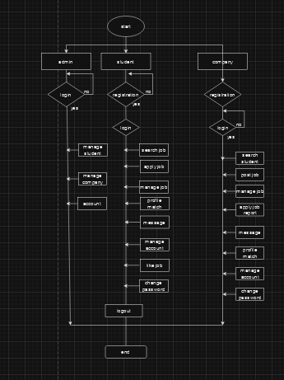

Figure 1 Flow Chart Diagram

## 5.3 DATAFLOW DIAGRAM OF THE PROPOSED SYSTEM

### DATA FLOW DIAGRAM

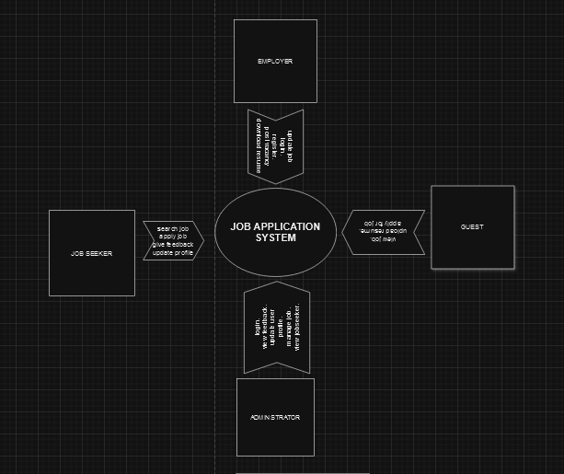

Figure 2 Data Flow Diagram

**ENTITY RELATIONSHIP DIAGRAM**

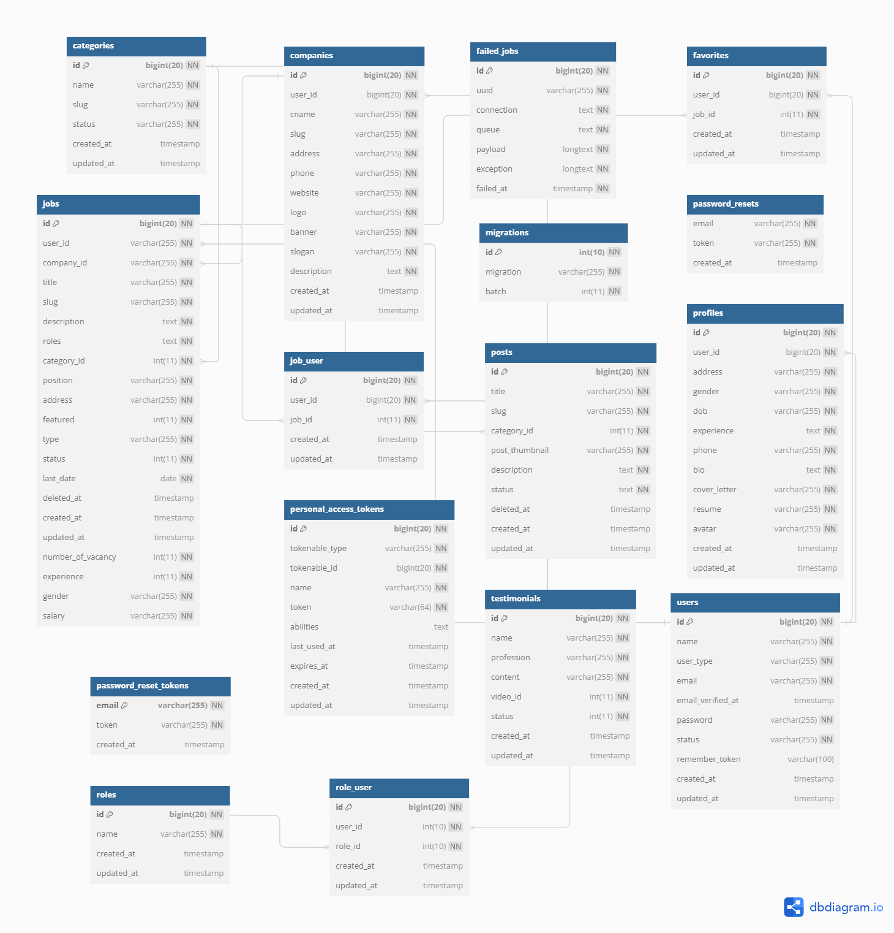

## 5.4 DATA DICTIONARY

### 5.4.1 DATABASE SCHEMA

### User Table

The user table contains information of every user been registered to the system.

|  |  |  |
| --- | --- | --- |
| **Field** | **Datatype** | **Description** |
| id | int (20) | User ID |
| name | varchar (20) | User Name |
| email | varchar (20) | User Email |
| email_verified_at | timestamp | Time and Date user email was verified |
| user_type | varchar (20) | Job Seeker, Company or Admin |
| password | varchar (20) | Password |
| created_at | timestamp | Creation Date |
| updated_at | timestamp | Updation Date |

### 

### Company table

The booking table maintains information of all done by job applicant s who want to go for tour.

|  |  |  |
| --- | --- | --- |
| **Field** | **datatype** | **Description** |
| id | int (20) | Company ID |
| user_id | int (20) | User ID |
| cname | varchar (20) | Company Name |
| address | varchar (20) | Company Address |
| phone | varchar (20) | Company Phone |
| Website | varchar (20) | Company Website |
| logo | varchar (20) | Company Logo |
| banner | Varchar (20) | Company Banner |
| slogan | varchar (20) | Company Slogan |
| description | Varchar (20) | Company Description |
| created_at | timestamp | Creation Date |
| Updated_at | timestamp | Updation Date------------------ |

### Job table

The enquiry table contains information on all enquiries made each job applicant.

|  |  |  |
| --- | --- | --- |
| **Field** | **Datatype** | **description** |
| id | int (20) | Job ID |
| user_id | int (20) | User ID |
| company_id | int (20) | Company ID |
| title | varchar (20) | Job Title |
| description | varchar (20) | Job Description |
| roles | varchar (20) | Job Role |
| category_id | Int (20) | Category ID |
| type | varchar (20) | Job Type |
| gender | varchar (20) | Job Gender |
| salary | varchar (20) | Job Salary |
| experience | int (20) | Job Experience |
| number_of_vacancy | int (20) | Number of Vacancy |
| last_date | date | Posting Date |
| created_at | timestamp | Creation Date |
| updated_at | timestamp | Updating Date |

### 

### Category table

The building table contains information on all issues that the job applicant s face when using the system

|  |  |  |
| --- | --- | --- |
| **Field** | **Datatype** | **Description** |
| id | Int (10) | Category ID |
| name | varchar (255) | Category Name |
| slug | varchar (10) | Category Slug |
| status | varchar (20) | Category Status |
| created_at | timestamp | Creation Date |
| updated_at | timestamp | Updating Date |

### 

### Favorite Job table

The favorite job table contains information on saved jobs by job seekers.

|  |  |  |
| --- | --- | --- |
| **Field** | **Datatype** | **Description** |
| id | int (5) | ID |
| user_id | int (20) | Job application ID |
| job_id | int (20) | Job ID |
| created_at | timestamp | Creation Date |
| updated_at | timestamp | Updation Date |

### Job User table

The job user table contains job applied information by job seekers.

|  |  |  |
| --- | --- | --- |
| **Field** | **Datatype** | **Description** |
| id | int (5) | ID |
| user_id | int (20) | Job application ID |
| job_id | int (20) | Job ID |
| created_at | timestamp | Creation Date |
| updated_at | timestamp | Updation Date |

### Post table

The post table contains a short description message or post from the admin.

|  |  |  |
| --- | --- | --- |
| **Field** | **Datatype** | **Description** |
| id | int (5) | ID |
| category_id | int (20) | Category ID |
| title | varchar (20) | Post Title |
| description | varchar (20) | Post Description |
| created_at | timestamp | Creation Date |
| updated_at | timestamp | Updation Date |

### Testimonial table

The testimonial table contains testimonies from job seekers.

|  |  |  |
| --- | --- | --- |
| **Field** | **Datatype** | **Description** |
| id | int (5) | ID |
| name | varchar (20) | Author Name |
| profession | varchar (20) | Author Profession |
| content | varchar (255) | Author testimonial info |
| created_at | timestamp | Creation Date |
| updated_at | timestamp | Updation Date |

### Profiles table

The profiles table contains job seekers profile information

|  |  |  |
| --- | --- | --- |
| **Field** | **Datatype** | **description** |
| id | int (20) | PROFILE ID |
| user_id | int (20) | User ID |
| address | Varchar (20) | Job Seeker Address |
| gender | varchar (20) | Job Seeker Gender |
| dob | varchar (20) | Job Seeker Date of Birth |
| experience | varchar (50) | Job Seeker Experience |
| phone | varchar (20) | Job Seeker Phone |
| bio | varchar (255) | Job Seeker BIO |
| cover_letter | varchar (20) | Job Seeker Cover Letter |
| resume | varchar (20) | Job Seeker Resume |
| avatar | int (20) | Job Seeker Profile Picture |
| created_at | timestamp | Creation Date |
| updated_at | timestamp | Updating Date |

## 5.5 USE CASE DIAGRAM

# CHAPTER 6

# SYSTEM IMPLEMENTATION AND TESTING

## 6.0 IMPLEMNTATION

1. Requirements

The system can be run on phone and computers and any other device with screen display that has access to internet. The system is hosted online which makes it easy to access from everywhere and anytime.

1. Design

The interface is also responsive and works with all mobile device and computers

1. Development

The system is developed with php for the web interface and system and mysql was used for the database and can be run with xammp

1. User Authentication

Two ways authentication feature was added to the system to intensify data security.

## 6.1 TESTING

1. Functional Test

The proposed system was tested based on its functions outlined and it passed.

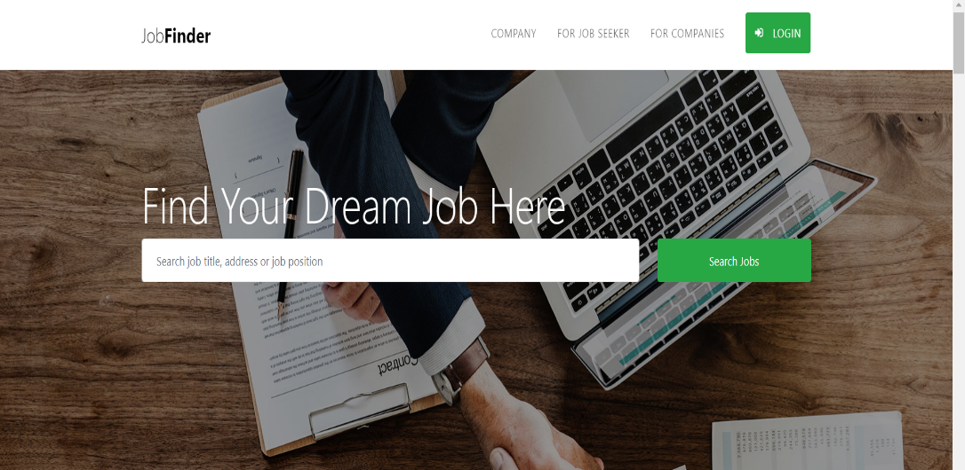

2. Performance Testing

The proposed system was tested based on its performance and its ability to meet the needs of users and it passed

1. Security Testing

The proposed system was able reject unauthorized users who does not have account on the system

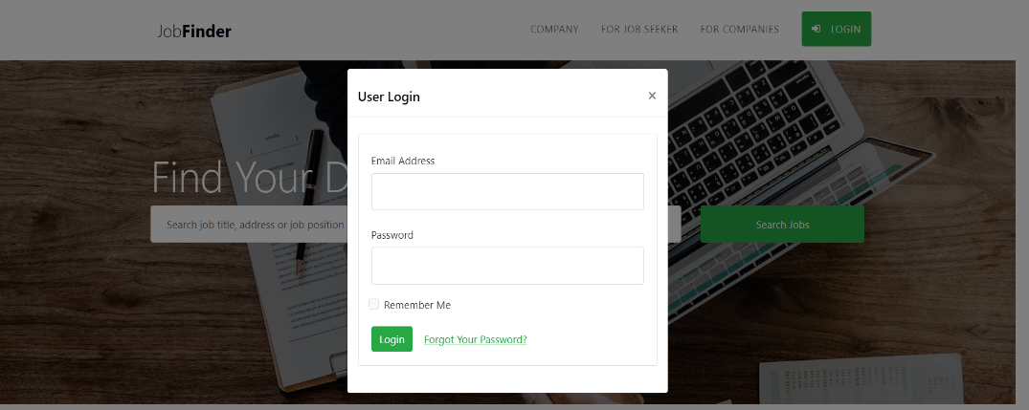

# CHAPTER 7

# CUNCLUSION AND RECOMMENDATION

## 8.0 CONCLUSION

Throughout the development and testing phases, several key observations and accomplishments have been made:

User-Friendly Interface: The user interface has been carefully designed to be intuitive and visually appealing, ensuring that users can easily navigate the system to find their desired travel destinations and job applications.

Responsive Design: Our platform is responsive, providing a consistent experience across various devices, including desktops, tablets, and smartphones.

Customer Support: Our dedicated customer support team has been instrumental in addressing user inquiries and issues promptly, enhancing overall user satisfaction.

Performance and Scalability: Extensive performance testing has been conducted to ensure that the system can handle a large number of concurrent users without significant performance degradation.

REFERENCE

1. <https://www.scribd.com/document/310278014/Online-Job-Portal-Documentation>
2. <https://github.com/topics/job-portal>
3. <https://www.researchgate.net/publication/348295543_A_Online_Job_portal_management_system>
4. <https://data-flair.training/blogs/online-job-portal-python-project/>
5. <https://dl.ucsc.cmb.ac.lk/jspui/bitstream/123456789/4284/1/2014MIT049.pdf>